A Project Report
on
PRODUCT RECOMMENDATION SYSTEM USING ML TECHNIQUES
submitted in partial fulfillment of the requirements for the award of the degree of
BACHELOR OF TECHNOLOGY
in
COMPUTER SICENCE AND ENGINEERING

by
17WH1A0585 Ms. T. HARIPRIYA
17WH1A05B1 Ms. M. MEGHANA
18WH5A0512 Ms. M. SRAVANTHI

under the esteemed guidance of
Mr. C.Nagaraju
Assistant Professor



Department of Computer Science and Engineering
BVRIT HYDERABAD
College of Engineering for Women
(NBA Accredited – EEE, ECE, CSE and IT)
(Approved by AICTE, New Delhi and Affiliated to JNTUH, Hyderabad)
Bachupally, Hyderabad – 500090

May, 2021
DECLARATION

We hereby declare that the work presented in this project entitled “PROJECT RECOMMENDATION SYSTEM USING ML TECHNIQUES” submitted towards completion of Project Work in IV year of B.Tech., CSE at ‘BVRIT HYDERABAD College of Engineering For Women’, Hyderabad is an authentic record of our original work carried out under the guidance of Mr.C.Nagaraju, Assistant Professor, Department of CSE.

Sign. with date:
Ms. T. HARIPRIYA
(17WH1A0585)

Sign. with date:
Ms. M. MEGHANA
(17WH1A05B1)

Sign. with date:
Ms. M. SRAVANTHI
(18WH5A0512)

BVRIT HYDERABAD
College of Engineering for Women
(NBA Accredited – EEE, ECE, CSE and IT)
(Approved by AICTE, New Delhi and Affiliated to JNTUH, Hyderabad)
Bachupally, Hyderabad – 500090

Department of Computer Science and Engineering



Certificate

This is to certify that the Project Work report on “PROJECT RECOMMENDATION SYSTEM USING ML TECHNIQUES” is a bonafide work carried out by Ms. T.HARIPRIYA (17WH1A0585) ; Ms. M.MEGHANA (17WH1A05B1) ; Ms. M.SRAVANTHI (18WH5A0512) in the partial fulfillment for the award of B.Tech. degree in Computer Science and Engineering, BVRIT HYDERABAD College of Engineering for Women, Bachupally, Hyderabad, affiliated to Jawaharlal Nehru Technological University Hyderabad, Hyderabad under my guidance and supervision.

The results embodied in the project work have not been submitted to any other University or Institute for the award of any degree or diploma.

Head of the Department Guide
Dr. K.Srinivas reddy Mr. C.Nagaraju
Professor and HoD, Assistant Professor
Department of CSE

External Examiner
Acknowledgements

We would like to express our sincere thanks to Dr. K V N Sunitha, Principal, BVRIT HYDERABAD College of Engineering for Women, for providing the working facilities in the college.

Our sincere thanks and gratitude to our Dr. K.Srinivas Reddy, Professor, Department of CSE, BVRIT HYDERABAD College of Engineering for Women for all the timely support and valuable suggestions during the period of our project.

We are extremely thankful and indebted to our internal guide, Mr. C.Nagaraju, Assistant Professor, Department of CSE, BVRIT HYDERABAD College of Engineering for Women for his constant guidance, encouragement and moral support throughout the project.

Finally, we would also like to thank our Project Coordinator, all the faculty and staff of CSE Department who helped us directly or indirectly, parents and friends for their cooperation in completing the project work.

Ms. T. Haripriya
(17WH1A0585)

Ms. M. Meghana
(17WH1A05B1)

Ms. M. Sravanthi
(18WH5A0512)

Contents

S.No. | Topic | Page No.
 | Abstract | i
 | List of Figures | ii
1. | Introduction | 1
 | 1.1 Objectives | 1
 | 1.2 Methodology | 1
 | 1.2.1 Dataset | 1
 | 1.2.2 The Proposed recommendation model | 4
 | 1.3 Organization of Project | 7
2. | Theoretical Analysis of the proposed project | 8
 | 2.1 Requirements Gathering | 8
 | 2.1.1 Software Requirements | 8
 | 2.1.2 Hardware Requirements | 8
 | 2.2 Technologies Description | 8
3. | Design | 17
 | 3.1 Introduction | 17
 | 3.2 Architecture Diagram | 17
 | 3.3 UML Diagrams | 18
 | 3.3.1 Use Case Diagram | 18
 | 3.3.2 Sequence Diagram | 19
 | 3.3.3 Activity Diagram | 20
 | 3.3.4 Collaboration Diagram | 21
 | 3.3.5 Class Diagram | 21
4. | Implementation | 23
 | 4.1 Coding | 23
 | 4.2 Testing | 51
 | 4.2.1 Testing Strategies | 52
 | 4.3 Output Screenshots | 57
5. | Conclusion and Future Scope | 61
6. | References | 62
Abstract
A product recommendation is basically a filtering system that seeks to predict and show the items that a user would like to purchase. Recommender system have become increasingly popular in recent years, and are utilized in a variety of areas including movies, music, news, books, research articles, search queries, social tags, and products in general. Mostly used in the digital domain, majority of today’s E-Commerce sites like eBay, Amazon, Alibaba etc. make use of their proprietary recommendation algorithms in order to better serve the customers with the products they are bound to like. Moreover, they can have positive effects on the user experience as well, which translates into metrics that are harder to measure but are nonetheless of much importance to online businesses, such as customer satisfaction and retention. All this is only possible with a recommendations engine. Recommendation engines basically are data filtering tools that make use of algorithms and data to recommend the most relevant items to a particular user.

List of Figures

S.No. | Figure Name | Page No.
1. | Ratings Electronics Dataset | 2
2. | Data Preprocessing | 3
3. | Collaborative Filtering Model | 4
4. | Architecture Diagram | 11
5. | Use Case Diagram | 12
6. | Sequence Diagram | 12
7. | Activity Diagram | 13
8. | Collaboration Diagram | 14
9. | Class Diagram | 14
10. | RMSE result for SVD Model | 28
11. | Result for Personal Recommendation Model | 29
12. | RMSE result for SVDpp Model | 30
13. | Evaluating Results | 30
14. | Recommendation using SVD Model | 31

1. INTRODUCTION
Product recommendation systems are typically used by companies, especially e-commerce companies like Amazon.com, to help users discover items they might not have found by themselves and promote sales to potential customers. A good recommendation system can provide customers with the most relevant products. This is a highly-targeted approach which can generate high conversion rate and make it very effective and smooth to do advertisements. So the problem we are trying to study here is that, how to build effective recommendation systems that can predict products that customers like the most and have the most potential to buy.

  - Objectives
The objective of recommendation systems is to provide recommendations based on recorded information on the users preferences. These systems use information filtering techniques to process information and provide the user with potentially more relevant items. This section presents collaborative filtering techniques based on users and items. We developed a recommendation system which enables bidirectional communication between the user and system using recommendation models in order to provide more dynamic and personalized recommendations. Recommendation models consist of Popularity based recommendation model and Collaborative filtering model. They can be used to predict the rating for a product that a customer has never reviewed, based on the data of all other users and their ratings in the system.

1.2 Methodology
The measure of data in this world is expanding more rapidly than our capacity to process it. A filtering system that seeks to predict and show the items that a user would like to purchase. In this section the methodology followed is discussed in detail

    - Dataset
Proper and large dataset is required for all classiﬁcation research during the training and the testing phase. The dataset for the System is downloaded from the Kaggle database which contains UserId, Productid, Rating, Timestamp. A dataset containing 4201696 unique values for the respective product is downloaded. Since we have split the data into testing and training we will need to create two [943 x 1682] matrices .The training matrix contains 75% of the ratings and the testing matrix contains 25% of the ratings.After we have built the user-item matrix we calculated the similarity and create a similarity matrix.

Ratings_Electronics.csv: Contains user Id, Product Id, Ratings and timestamp
User Id | Product Id | Ratings | timestamp
A2CX7LUOHB2NDG | 0321732944 | 5.0 | 1341100800
A2NWSAGRHCP8N5 | 0439886341 | 1.0 | 1367193600
A2WNBOD3WNDNKT | 0439886341 | 3.0 | 1374451200
A1GI0U4ZRJA8WN | 0439886341 | 1.0 | 1334707200
A1QGNMC6O1VW39 | 0511189877 | 5.0 | 1397433600
A3J3BRHTDRFJ2G | 0511189877 | 2.0 | 1397433600
Fig 1.2.1: Ratings Electronics Dataset

1.2.2 The Proposed recommendation model
A Recommendation system which enables bidirectional communication between the user and system using recommendation models in order to provide more dynamic and personalized recommendations. Recommendation models consist of Popularity based recommendation model and Collaborative filtering model.
Data Preprocessing:
Data preprocessing is a crucial step for any data analysis problem. The model's accuracy depends mostly on the quality of the data. In general, any data preprocessing step involves data cleansing, transformations, identifying missing values, and how they should be treated. Only the preprocessed data can be fed into a machine-learning algorithm. In this section, we will focus mainly on data preprocessing techniques. These techniques include similarity measurements (such as Euclidean distance, Cosine distance, and Pearson coefficient) and dimensionality-reduction techniques, such as Principal component analysis (PCA), which are widely used in recommender systems. Sometimes we may find some data are missing in the dataset. If we found then we will remove those rows or we can calculate either mean, mode or median of the feature and replace it with missing values.
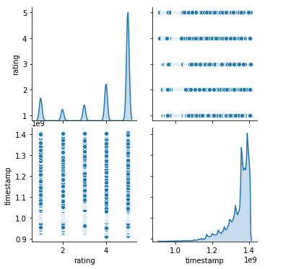
Fig 1.2.2: Data Preprocessing

Popularity Recommendation Model:
In popularity based recommendation model, Every user gets the products according to the product ratings. The recommendations for each user is the same products.
That is so because each user gets recommended with the products which have had the top five average ratings, irrespective of what the users personal preferences are.
In the output there are 4 columns which contains the information about userid, productid, score, rank. The column score gives the information about the count of no.of users who rated that particular product. The products which have high ratings have the highest priority.
Collaborative filtering-based systems:
These systems recommend products to a user that similar users have liked. For measuring the similarity between two users we can either use 16 pearson correlation or cosine similarity. It is dependent on the relation between users which implies that it is content-independent. Collaborative Filtering recommender systems can suggest items by observing similar-minded people’s behavior. They can make real quality assessment of items by considering other people’s experience. Memory-Based Collaborative Filtering approaches can be divided into two main sections: user-item filtering and item-item filtering. A user-item filtering will take a particular user, find users that are similar to that user based on similarity of ratings, and recommend items that those similar users liked. In contrast, item-item filtering will take an item, find users who liked that item, and find other items that those users or similar users also liked. It takes items and outputs other items as recommendations. Item-Item Collaborative Filtering: “Users who liked this item also liked …”User-Item Collaborative Filtering: “Users who are similar to you also liked …”In both cases, we create a user-item matrix which built from the entire dataset. The similarity values between items in Item-Item Collaborative Filtering are measured by observing all the users who have rated both items. For User-Item Collaborative Filtering the similarity values between users are measured by observing all the items that are rated by both users.A distance metric commonly used in recommender systems is cosine similarity, where the ratings are seen as vectors in n-dimensional space and the similarity is calculated based on the angle between these vectors. Cosine similiarity for users a and m can be calculated using the formula below, where you take dot product of the user vector $u_k$ and the user vector $u_a$ and divide it by multiplication of the Euclidean lengths of the vectors.

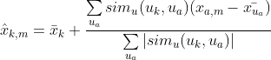

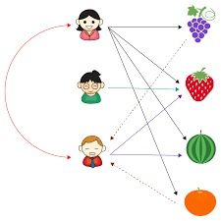
Fig 1.2.3: Collaborative Filtering Model

1.3 Organization of Project
It finds information designs in the informational index by learning customers decisions and produces the results that co-identifies with their requirements We have three modules in our project.
- Data Preprocessing
- Popularity Recommendation Model
- Collaborative Filtering Model

2. THEORETICAL ANALYSIS OF THE PROPOSED PROJECT
2.1 Requirements Gathering
2.1.1 Software Requirements
Programming Language: Python 3.6
Dataset : Rating Electronics
Packages : Numpy, Pandas, Matplotlib, Scikit-learn
Tool : Jupiter Notebook
2.1.2 Hardware Requirements
Operating System: Windows 10
Processor : Intel Core i3-2348M
CPU Speed : 2.30 GHz
Memory : 2 GB (RAM)

2.2 Technologies Description
Python
Python is an interpreted high-level programming language for general-purpose programming. Created by Guido van Rossum and first released in 1991, Python has a design philosophy that emphasizes code readability, notably using significant whitespace.
Python features a dynamic type system and automatic memory management. It supports multiple programming paradigms, including object-oriented, imperative, functional and procedural, and has a large and comprehensive standard library.
- Python is Interpreted − Python is processed at runtime by the interpreter. You do not need to compile your program before executing it. This is similar to PERL and PHP.
- Python is Interactive − you can actually sit at a Python prompt and interact with the interpreter directly to write your programs.
Python also acknowledges that speed of development is important. Readable and terse code is part of this, and so is access to powerful constructs that avoid tedious repetition of code. Maintainability also ties into this may be an all but useless metric, but it does say something about how much code you have to scan, read and/or understand to troubleshoot problems or tweak behaviors. This speed of development, the ease with which a programmer of other languages can pick up basic Python skills and the huge standard library is key to another area where Python excels. All its tools have been quick to implement, saved a lot of time, and several of them have later been patched and updated by people with no Python background - without breaking.
Numpy
Numpy is a general-purpose array-processing package. It provides a high-performance multidimensional array object, and tools for working with these arrays.
It is the fundamental package for scientific computing with Python. It contains various features including these important ones:
- A powerful N-dimensional array object
- Sophisticated (broadcasting) functions
- Tools for integrating C/C++ and Fortran code
- Useful linear algebra, Fourier transform, and random number capabilities
Besides its obvious scientific uses, Numpy can also be used as an efficient multi-dimensional container of generic data. Arbitrary data-types can be defined using Numpy which allows Numpy to seamlessly and speedily integrate with a wide variety of databases.
Pandas
Pandas is an open-source Python Library providing high-performance data manipulation and analysis tool using its powerful data structures. Python was majorly used for data munging and preparation. It had very little contribution towards data analysis. Pandas solved this problem. Using Pandas, we can accomplish five typical steps in the processing and analysis of data, regardless of the origin of data load, prepare, manipulate, model, and analyze. Python with Pandas is used in a wide range of fields including academic and commercial domains including finance, economics, Statistics, analytics, etc.
Matplotlib
Matplotlib is a Python 2D plotting library which produces publication quality figures in a variety of hardcopy formats and interactive environments across platforms. Matplotlib can be used in Python scripts, the Python and IPython shells, the Jupyter Notebook, web application servers, and four graphical user interface toolkits. Matplotlib tries to make easy things easy and hard things possible. You can generate plots, histograms, power spectra, bar charts, error charts, scatter plots, etc., with just a few lines of code. For examples, see the sample plots and thumbnail gallery.
For simple plotting the pyplot module provides a MATLAB-like interface, particularly when combined with IPython. For the power user, you have full control of line styles, font properties, axes properties, etc, via an object oriented interface or via a set of functions familiar to MATLAB users.
Scikit – learn
Scikit-learn provides a range of supervised and unsupervised learning algorithms via a consistent interface in Python. It is licensed under a permissive simplified BSD license and is distributed under many Linux distributions, encouraging academic and commercial use. The library is built upon the SciPy (Scientific Python) that must be installed before you can use scikit-learn. This stack that includes:
- NumPy: Base n-dimensional array package
- SciPy: Fundamental library for scientific computing
- Matplotlib: Comprehensive 2D/3D plotting
- IPython: Enhanced interactive console
- Sympy: Symbolic mathematics
- Pandas: Data structures and analysis
- Extensions or modules for SciPy care conventionally named SciKits. As such, the module provides learning algorithms and is named scikit-learn.

Jupyter Notebook
The Jupyter Notebook is an open source web application that you can use to create and share documents that contain live code, equations, visualizations, and text. Jupyter Notebook is maintained by the people at Project Jupyter.
Jupyter Notebooks are a spin-off project from the IPython project, which used to have an IPython Notebook project itself. The name, Jupyter, comes from the core supported programming languages that it supports: Julia, Python, and R. Jupyter ships with the IPython kernel, which allows you to write your programs in Python, but there are currently over 100 other kernels that you can also use.

3. DESIGN
3.1 Introduction
Software design sits at the technical kernel of the software engineering process and is applied regardless of the development paradigm and area of application. Design is the first step in the development phase for any engineered product or system. The designer’s goal is to produce a model or representation of an entity that will later be built. Beginning, once system requirement have been specified and analyzed, system design is the first of the three technical activities -design, code and test that is required to build and verify software.
The importance can be stated with a single word “Quality”. Design is the place where quality is fostered in software development. Design provides us with representations of software that can assess for quality. Design is the only way that we can accurately translate a customer’s view into a finished software product or system. Software design serves as a foundation for all the software engineering steps that follow. Without a strong design we risk building an unstable system – one that will be difficult to test, one whose quality cannot be assessed until the last stage.
During design, progressive refinement of data structure, program structure, and procedural details are developed reviewed and documented. System design can be viewed from either technical or project management perspective. From the technical point of view, design is comprised of four activities – architectural design, data structure design, interface design and procedural design.

3.2 Architecture Diagram
Web applications are by nature distributed applications, meaning that they are programs that run on more than one computer and communicate through network or server. Specifically, web applications are accessed with a web browser and are popular because of the ease of using the browser as a user client. For the enterprise, software on potentially thousands of client computers is a key reason for their popularity. Web applications are used for web mail, online retail sales, discussion boards, weblogs, online banking, and more. One web application can be accessed and used by millions of people.
Like desktop applications, web applications are made up of many parts and often contain mini programs and some of which have user interfaces. In addition, web applications frequently require an additional markup or scripting language, such as HTML, CSS, or JavaScript programming language. Also, many applications use only the Python programming language, which is ideal because of its versatility.
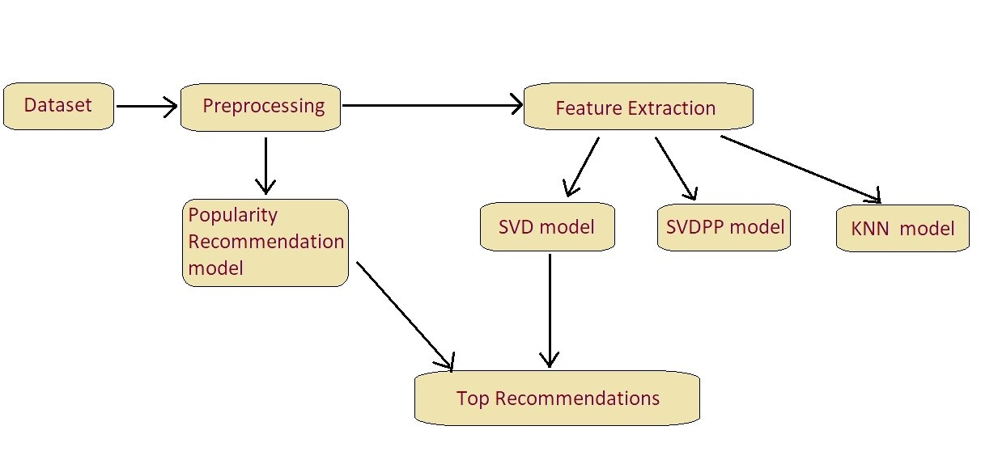
Fig 3.2: Architecture Diagram

3.3 UML Diagrams
3.3.1 Use Case Diagram
To model a system, the most important aspect is to capture the dynamic behavior. Dynamic behavior means the behavior of the system when it is running/operating.
Only static behavior is not sufficient to model a system rather dynamic behavior is more important than static behavior. In UML, there are five diagrams available to model the dynamic nature and use case diagram is one of them. Now as we have to discuss that the use case diagram is dynamic in nature, there should be some internal or external factors for making the interaction.
These internal and external agents are known as actors. Use case diagrams consist of actors, use cases and their relationships. The diagram is used to model the system/subsystem of an application. A single use case diagram captures a particular functionality of a system.
Hence to model the entire system, a number of use case diagrams are used.
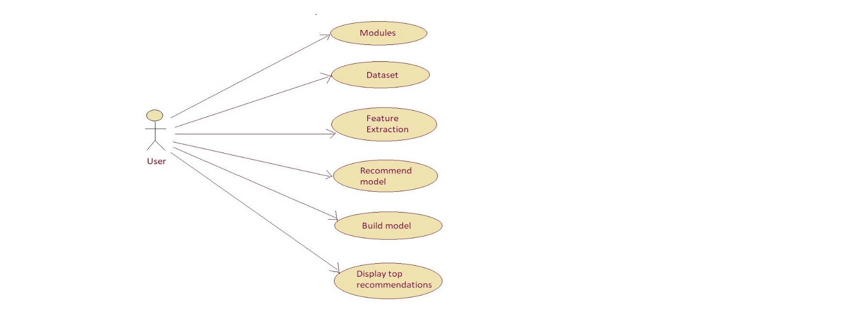

Fig 3.2.1: Use Case Diagram

3.3.2 Sequence Diagram
Sequence Diagrams Represent the objects participating the interaction horizontally and time vertically. A Use Case is a kind of behavioral classifier that represents a declaration of an offered behavior. Each use case specifies some behavior, possibly including variants that the subject can perform in collaboration with one or more actors. Use cases define the offered behavior of the subject without reference to its internal structure. These behaviors, involving interactions between the actor and the subject, may result in changes to the state of the subject and communications with its environment. A use case can include possible variations of its basic behavior, including exceptional behavior and error handling.
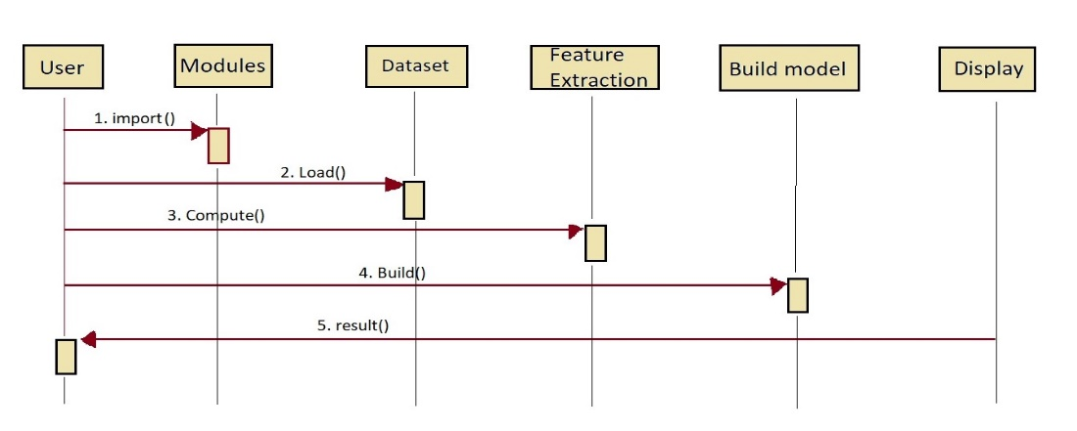
Fig 3.3.2: Sequence Diagram

3.3.3 Activity Diagram
Activity diagrams are graphical representations of Workflows of stepwise activities and actions with support for choice, iteration and concurrency. In the Unified Modeling Language, activity diagrams can be used to describe the business and operational step-by-step workflows of components in a system. An activity diagram shows the overall flow of control.
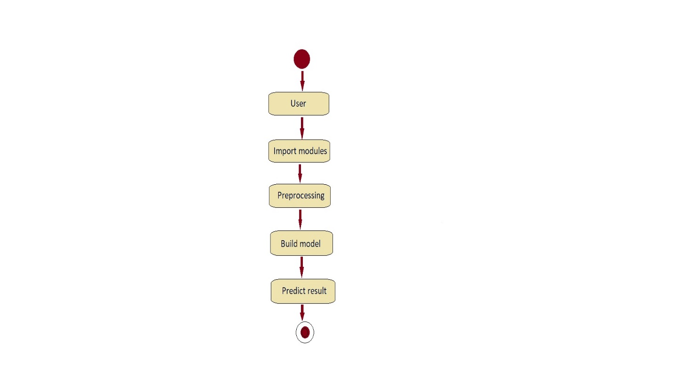
Fig 3.2.3: Activity Diagram
3.3.4 Collaboration Diagram
A collaboration diagram resembles a flowchart that portrays the roles, functionality and behavior of individual objects as well as the overall operation of the system in real time. Objects are shown as rectangles with naming labels inside. These labels are preceded by colons and may be underlined. The relationships between the objects are shown as lines connecting the rectangles. The messages between objects are shown as arrows connecting the relevant rectangles along with labels that define the message sequencing.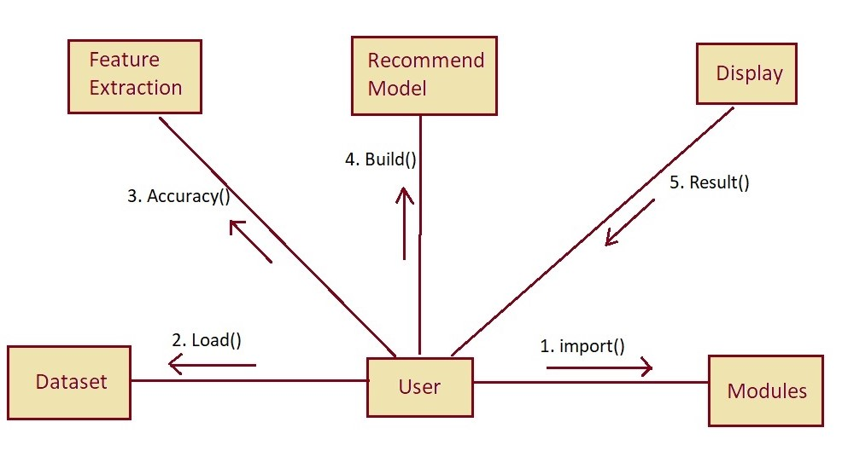

Fig 3.2.4:Collabration Diagram

3.3.5 Class Diagram
The class diagram is the main building block of object-oriented modeling. It is used for general conceptual modeling of the systematic of the application, and for detailed modeling translating the models into programming code. Class diagrams can also be used for data modeling. The classes in a class diagram represent both the main elements, interactions in the application, and the classes to be programmed.

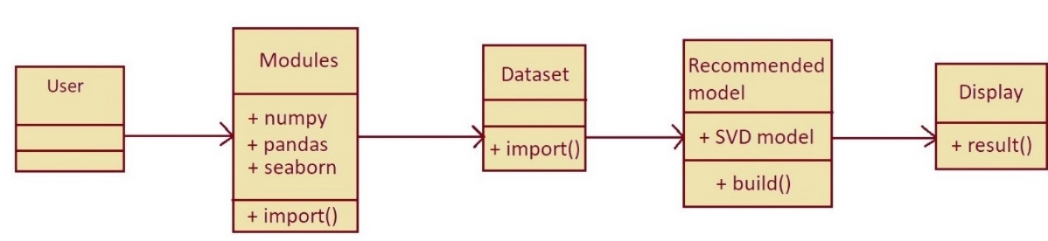
Fig 3.2.5: Class Diagram

4. IMPLEMENTATION
4.1 Coding
pip install scikit-surprise

import numpy as np
import pandas as pd
import seaborn as sns
import matplotlib.pyplot as plt

from collections import defaultdict
from surprise import KNNWithMeans
from surprise import SVD, SVDpp
from surprise import KNNBaseline
from surprise import KNNBasic
from surprise import KNNWithZScore
from surprise import BaselineOnly
from surprise import Dataset
from surprise import Reader
from surprise import accuracy
from surprise.model_selection import train_test_split
from surprise.model_selection import cross_validate
from surprise.model_selection import KFold
from surprise.model_selection import GridSearchCV
import time

from google.colab import drive
drive.mount('/content/drive')

df = pd.read_csv('/content/drive/MyDrive/Project/ratings_Electronics.csv', names=["userId", "productId", "rating", "timestamp"])
df.head()

rows_count, columns_count = df.shape
print('Total Number of rows :', rows_count)
print('Total Number of columns :', columns_count)

unique_userId = df['userId'].nunique()
unique_productId = df['productId'].nunique()
print('Total number of unique Users : ', unique_userId)
print('Total number of unique Products : ', unique_productId)

df.apply(lambda x : sum(x.isnull()))

df.isnull().sum()

df.isna().any()

df['rating'].value_counts()

rating_counts = pd.DataFrame(df['rating'].value_counts()).reset_index()
rating_counts.columns = ['Labels', 'Ratings']
rating_counts

df = df.drop(['timestamp'], axis=1)

df1 = df.copy()

users_counts = df1['userId'].value_counts().rename('users_counts')
users_data = df1.merge(users_counts.to_frame(),left_on='userId',right_index=True)
subset_df = users_data[users_data.users_counts >= 50]
subset_df

product_rating_counts = subset_df['productId'].value_counts().rename('product_rating_counts')
product_rating_data = subset_df.merge(product_rating_counts.to_frame(),left_on='productId',right_index=True)

product_rating_data = product_rating_data[product_rating_data.product_rating_counts >= 10]
product_rating_data

electronics_data_df = product_rating_data.copy()

panda_data = electronics_data_df.drop(['users_counts', 'product_rating_counts'], axis=1)

k = 5
reader = Reader(rating_scale=(1, 5))
reader
surprise_data = Dataset.load_from_df(panda_data[['userId', 'productId', 'rating']], reader)
surprise_data

trainset, testset = train_test_split(surprise_data, test_size=.30, random_state=7)
trainset

panda_data.groupby('productId')['rating'].mean().head()

panda_data.groupby('productId')['rating'].mean().sort_values(ascending=False).head()

prod_rating_count = pd.DataFrame(panda_data.groupby('productId')['rating'].mean().sort_values(ascending=False))
prod_rating_count['prod_rating_count'] = pd.DataFrame(panda_data.groupby('productId')['rating'].count())

basic_poplurity_model = prod_rating_count.sort_values(by=['prod_rating_count'], ascending=False)

#Ranking based Algorithms
#Count of user_id for each unique song as recommendation score
panda_data_grouped = panda_data.groupby('productId').agg({'userId': 'count'}).reset_index()
print(panda_data_grouped)
panda_data_grouped.rename(columns = {'userId': 'score'},inplace=True)
panda_data_grouped

panda_data_sort = panda_data_grouped.sort_values(['score', 'productId'], ascending = [0,1])

#Generate a recommendation rank based upon score
panda_data_sort['Rank'] = panda_data_sort['score'].rank(ascending=0, method='first')

#Get the top 5 recommendations
popularity_recommendations = panda_data_sort.head(k)
popularity_recommendations

# Using popularity based recommender model to make predictions
import warnings
warnings.filterwarnings('ignore')
def recommend(userId):
user_recommendations = popularity_recommendations
# print(user_recommendations)
#Adding user_id column for which the recommendations are being generated
user_recommendations['userID'] = userId

#Bringing user_id column to the front
cols = user_recommendations.columns.tolist()
cols = cols[-1:] + cols[:-1]
user_recommendations = user_recommendations[cols]

return user_recommendations

find_recom = [15,121,55,230,344] # This list is user choice.
for i in find_recom:
print("Here is the recommendation for the userId: %d\n" %(i))
print(recommend(i))
print("\n")

cv_results = [] # to store cross validation result

svd_param_grid = {'n_epochs': [20, 25], 'lr_all': [0.007, 0.009, 0.01], 'reg_all': [0.4, 0.6]}

svd_gs = GridSearchCV(SVD, svd_param_grid, measures=['rmse', 'mae'], cv=5, n_jobs=5)
svdpp_gs = GridSearchCV(SVDpp, svd_param_grid, measures=['rmse', 'mae'], cv=5, n_jobs=5)

svd_gs.fit(surprise_data)
svdpp_gs.fit(surprise_data)

# best RMSE score
print(svd_gs.best_score['rmse'])
print(svdpp_gs.best_score['rmse'])

# combination of parameters that gave the best RMSE score
print(svd_gs.best_params['rmse'])
print(svdpp_gs.best_params['rmse'])

start_time = time.time()

# Creating Model using best parameters
svd_model = SVD(n_epochs=20, lr_all=0.005, reg_all=0.2)

# Training the algorithm on the trainset
svd_model.fit(trainset)

# Predicting for test set
predictions_svd = svd_model.test(testset)

# Evaluating RMSE, MAE of algorithm SVD on 5 split(s) by cross validation
svd_cv = cross_validate(svd_model, surprise_data, measures=['RMSE', 'MAE'], cv=5, verbose=True)

# Storing Crossvalidation Results in dataframe
svd_df = pd.DataFrame.from_dict(svd_cv)
svd_described = svd_df.describe()
cv_results = pd.DataFrame([['SVD', svd_described['test_rmse']['mean'], svd_described['test_mae']['mean'],
svd_described['fit_time']['mean'], svd_described['test_time']['mean']]],
columns = ['Model', 'RMSE', 'MAE', 'Fit Time', 'Test Time'])

# get RMSE
print("\n\n==================== Model Evaluation ===============================")
accuracy.rmse(predictions_svd, verbose=True)
print("=====================================================================")
computational_time = time.time() - start_time
print('\n Computational Time : %0.3fs' %(computational_time))
cv_results

start_time = time.time()

# Creating Model using best parameters
svdpp_model = SVDpp(n_epochs=25, lr_all=0.01, reg_all=0.4)

# Training the algorithm on the trainset
svdpp_model.fit(trainset)

# Predicting for test set
predictions_svdpp = svdpp_model.test(testset)

# Evaluating RMSE, MAE of algorithm SVDpp on 5 split(s) by cross validation
svdpp_cv = cross_validate(svdpp_model, surprise_data, measures=['RMSE', 'MAE'], cv=5, verbose=True)

# Storing Crossvalidation Results in dataframe
svdpp_df = pd.DataFrame.from_dict(svdpp_cv)
svdpp_described = svdpp_df.describe()
svdpp_cv_results = pd.DataFrame([['SVDpp', svdpp_described['test_rmse']['mean'], svdpp_described['test_mae']['mean'],
svdpp_described['fit_time']['mean'], svdpp_described['test_time']['mean']]],
columns = ['Model', 'RMSE', 'MAE', 'Fit Time', 'Test Time'])

cv_results = cv_results.append(svdpp_cv_results, ignore_index=True)

# get RMSE
print("\n\n==================== Model Evaluation ===============================")
accuracy.rmse(predictions_svdpp, verbose=True)
print("=====================================================================")
computational_time = time.time() - start_time
print('\n Computational Time : %0.3fs' %(computational_time))
cv_results

start_time = time.time()

knn_param_grid = {'bsl_options': {'method': ['als', 'sgd'],
'reg': [1, 2]},
'k': [15, 20, 25, 30, 40, 50, 60],
'sim_options': {'name': ['msd', 'cosine', 'pearson_baseline']}
}

knnbasic_gs = GridSearchCV(KNNBasic, knn_param_grid, measures=['rmse', 'mae'], cv=5, n_jobs=5)
knnmeans_gs = GridSearchCV(KNNWithMeans, knn_param_grid, measures=['rmse', 'mae'], cv=5, n_jobs=5)
knnz_gs = GridSearchCV(KNNWithZScore, knn_param_grid, measures=['rmse', 'mae'], cv=5, n_jobs=5)

knnbasic_gs.fit(surprise_data)
knnmeans_gs.fit(surprise_data)
knnz_gs.fit(surprise_data)

# best RMSE score
print(knnbasic_gs.best_score['rmse'])
print(knnmeans_gs.best_score['rmse'])
print(knnz_gs.best_score['rmse'])

# combination of parameters that gave the best RMSE score
print(knnbasic_gs.best_params['rmse'])
print(knnmeans_gs.best_params['rmse'])
print(knnz_gs.best_params['rmse'])

computational_time = time.time() - start_time
print('\nComputational Time : %0.3fs' %(computational_time))

start_time = time.time()

# Creating Model using best parameters
knnBasic_model = KNNBasic(k=50, sim_options={'name': 'cosine', 'user_based': False})

# Training the algorithm on the trainset
knnBasic_model.fit(trainset)

# Predicting for test set
prediction_knnBasic = knnBasic_model.test(testset)

# Evaluating RMSE, MAE of algorithm KNNBasic on 5 split(s)
knnBasic_cv = cross_validate(knnBasic_model, surprise_data, measures=['RMSE', 'MAE'], cv=5, verbose=True)

# Storing Crossvalidation Results in dataframe
knnBasic_df = pd.DataFrame.from_dict(knnBasic_cv)
knnBasic_described = knnBasic_df.describe()
knnBasic_cv_results = pd.DataFrame([['KNNBasic', knnBasic_described['test_rmse']['mean'], knnBasic_described['test_mae']['mean'],
knnBasic_described['fit_time']['mean'], knnBasic_described['test_time']['mean']]],
columns = ['Model', 'RMSE', 'MAE', 'Fit Time', 'Test Time'])

cv_results = cv_results.append(knnBasic_cv_results, ignore_index=True)

# get RMSE
print("\n\n==================== Model Evaluation ===============================")
accuracy.rmse(prediction_knnBasic, verbose=True)
print("=====================================================================")

computational_time = time.time() - start_time
print('\n Computational Time : %0.3fs' %(computational_time))
cv_results

start_time = time.time()

# Creating Model using best parameters
knnZscore_model = KNNWithZScore(k=60, sim_options={'name': 'cosine', 'user_based': False})

# Training the algorithm on the trainset
knnZscore_model.fit(trainset)

# Predicting for testset
prediction_knnZscore = knnZscore_model.test(testset)

# Evaluating RMSE, MAE of algorithm KNNWithZScore on 5 split(s)
knnZscore_cv = cross_validate(knnZscore_model, surprise_data, measures=['RMSE', 'MAE'], cv=5, verbose=True)

# Storing Crossvalidation Results in dataframe
knnZscore_df = pd.DataFrame.from_dict(knnZscore_cv)
knnZscore_described = knnZscore_df.describe()
knnZscore_cv_results = pd.DataFrame([['KNNWithZScore', knnZscore_described['test_rmse']['mean'], knnZscore_described['test_mae']['mean'],
knnZscore_described['fit_time']['mean'], knnZscore_described['test_time']['mean']]],
columns = ['Model', 'RMSE', 'MAE', 'Fit Time', 'Test Time'])

cv_results = cv_results.append(knnZscore_cv_results, ignore_index=True)

# get RMSE
print("\n\n==================== Model Evaluation ===============================")
accuracy.rmse(prediction_knnZscore, verbose=True)
print("=====================================================================")

computational_time = time.time() - start_time
print('\n Computational Time : %0.3fs' %(computational_time))
cv_results

start_time = time.time()

# Creating Model using best parameters
knnMeansUU_model = KNNWithMeans(k=60, sim_options={'name': 'cosine', 'user_based': True})

# Training the algorithm on the trainset
knnMeansUU_model.fit(trainset)

# Predicting for testset
prediction_knnMeansUU = knnMeansUU_model.test(testset)

# Evaluating RMSE, MAE of algorithm KNNWithMeans User-User on 5 split(s)
knnMeansUU_cv = cross_validate(knnMeansUU_model, surprise_data, measures=['RMSE', 'MAE'], cv=5, verbose=True)

# Storing Crossvalidation Results in dataframe
knnMeansUU_df = pd.DataFrame.from_dict(knnMeansUU_cv)
knnMeansUU_described = knnMeansUU_df.describe()
knnMeansUU_cv_results = pd.DataFrame([['KNNWithMeans User-User', knnMeansUU_described['test_rmse']['mean'], knnMeansUU_described['test_mae']['mean'],
knnMeansUU_described['fit_time']['mean'], knnMeansUU_described['test_time']['mean']]],
columns = ['Model', 'RMSE', 'MAE', 'Fit Time', 'Test Time'])

cv_results = cv_results.append(knnMeansUU_cv_results, ignore_index=True)

# get RMSE
print("\n\n==================== Model Evaluation ===============================")
accuracy.rmse(prediction_knnMeansUU, verbose=True)
print("=====================================================================")

computational_time = time.time() - start_time
print('\n Computational Time : %0.3fs' %(computational_time))
cv_results

start_time = time.time()

# Creating Model using best parameters
knnMeansII_model = KNNWithMeans(k=60, sim_options={'name': 'cosine', 'user_based': False})

# Training the algorithm on the trainset
knnMeansII_model.fit(trainset)

# Predicting for testset
prediction_knnMeansII = knnMeansII_model.test(testset)

# Evaluating RMSE, MAE of algorithm KNNWithMeans Item-Item on 5 split(s)
knnMeansII_cv = cross_validate(knnMeansII_model, surprise_data, measures=['RMSE', 'MAE'], cv=5, verbose=True)

# Storing Crossvalidation Results in dataframe
knnMeansII_df = pd.DataFrame.from_dict(knnMeansII_cv)
knnMeansII_described = knnMeansII_df.describe()
knnMeansII_cv_results = pd.DataFrame([['KNNWithMeans Item-Item', knnMeansII_described['test_rmse']['mean'], knnMeansII_described['test_mae']['mean'],
knnMeansII_described['fit_time']['mean'], knnMeansII_described['test_time']['mean']]],
columns = ['Model', 'RMSE', 'MAE', 'Fit Time', 'Test Time'])

cv_results = cv_results.append(knnMeansII_cv_results, ignore_index=True)

# get RMSE
print("\n\n==================== Model Evaluation ===============================")
accuracy.rmse(prediction_knnMeansII, verbose=True)
print("=====================================================================")

computational_time = time.time() - start_time
print('\n Computational Time : %0.3fs' %(computational_time))
cv_results

x_algo = ['KNN Basic', 'KNNWithMeans-User-User', 'KNNWithMeans-Item-Item', 'KNN ZScore', 'SVD', 'SVDpp']
all_algos_cv = [knnBasic_cv, knnMeansUU_cv, knnMeansII_cv, knnZscore_cv, svd_cv, svdpp_cv]

rmse_cv = [round(res['test_rmse'].mean(), 4) for res in all_algos_cv]
mae_cv = [round(res['test_mae'].mean(), 4) for res in all_algos_cv]

plt.figure(figsize=(20,15))

plt.subplot(2, 1, 1)
plt.title('Comparison of Algorithms on RMSE', loc='center', fontsize=15)
plt.plot(x_algo, rmse_cv, label='RMSE', color='darkgreen', marker='o')
plt.xlabel('Algorithms', fontsize=15)
plt.ylabel('RMSE Value', fontsize=15)
plt.legend()
plt.grid(ls='dashed')

plt.subplot(2, 1, 2)
plt.title('Comparison of Algorithms on MAE', loc='center', fontsize=15)
plt.plot(x_algo, mae_cv, label='MAE', color='navy', marker='o')
plt.xlabel('Algorithms', fontsize=15)
plt.ylabel('MAE Value', fontsize=15)
plt.legend()
plt.grid(ls='dashed')

plt.show()

cv_results

#Create two user-item matrices, one for training and another for testing
train_data_matrix = np.zeros((n_users, n_items))
for line in train_data.itertuples():
train_data_matrix[line[1]-1, line[2]-1] = line[3]

test_data_matrix = np.zeros((n_users, n_items))
for line in test_data.itertuples():
test_data_matrix[line[1]-1, line[2]-1] = line[3]

from sklearn.metrics.pairwise import pairwise_distances
user_similarity = pairwise_distances(train_data_matrix, metric='cosine')
item_similarity = pairwise_distances(train_data_matrix.T, metric='cosine')

item_prediction = predict(train_data_matrix, item_similarity, type='item')
user_prediction = predict(train_data_matrix, user_similarity, type='user')

def predict(ratings, similarity, type='user'):
if type == 'user':
mean_user_rating = ratings.mean(axis=1)
#You use np.newaxis so that mean_user_rating has same format as ratings
ratings_diff = (ratings - mean_user_rating[:, np.newaxis])
pred = mean_user_rating[:, np.newaxis] + similarity.dot(ratings_diff) / np.array([np.abs(similarity).sum(axis=1)]).T
elif type == 'item':
pred = ratings.dot(similarity) / np.array([np.abs(similarity).sum(axis=1)])
return pred

import collections

top_n = collections.defaultdict(list)
print(top_n)
def get_top_n(predictions, n=5):
# First map the predictions to each user.
top_n = collections.defaultdict(list)
for uid, iid, true_r, est, _ in predictions:
top_n[uid].append((iid, est))

# Then sort the predictions for each user and retrieve the k highest ones.
for uid, user_ratings in top_n.items():
user_ratings.sort(key=lambda x: x[1], reverse=True)
top_n[uid] = user_ratings[:n]

return top_n

top_n = get_top_n(predictions_svd, n=5)
top_n

#from scipy.linalg import svd
from surprise import SVD,NormalPredictor
def precision_recall_at_k(predictions, k=5, threshold=3.5):
'''Return precision and recall at k metrics for each user.'''

# First map the predictions to each user.
user_est_true = defaultdict(list)
for uid, _, true_r, est, _ in predictions:
user_est_true[uid].append((est, true_r))

precisions = dict()
recalls = dict()
for uid, user_ratings in user_est_true.items():

# Sort user ratings by estimated value
user_ratings.sort(key=lambda x: x[0], reverse=True)

# Number of relevant items
n_rel = sum((true_r >= threshold) for (_, true_r) in user_ratings)

# Number of recommended items in top k
n_rec_k = sum((est >= threshold) for (est, _) in user_ratings[:k])

# Number of relevant and recommended items in top k
n_rel_and_rec_k = sum(((true_r >= threshold) and (est >= threshold))
for (est, true_r) in user_ratings[:k])

# Precision@K: Proportion of recommended items that are relevant
precisions[uid] = n_rel_and_rec_k / n_rec_k if n_rec_k != 0 else 1

# Recall@K: Proportion of relevant items that are recommended
recalls[uid] = n_rel_and_rec_k / n_rel if n_rel != 0 else 1

return precisions, recalls

kf = KFold(n_splits=5)
svd_model = SVD(n_epochs=20, lr_all=0.005, reg_all=0.2)
precs = []
recalls = []

for trainset, testset in kf.split(surprise_data):
svd_model.fit(trainset)
predictions = svd_model.test(testset)
precisions, recalls = precision_recall_at_k(predictions, k=5, threshold=3.5)

# Precision and recall can then be averaged over all users
print('Precision : ', sum(prec for prec in precisions.values()) / len(precisions))
print('recalls : ',sum(rec for rec in recalls.values()) / len(recalls))

4.2 Testing
Software testing is a critical element of software quality assurance and represents the ultimate review of specification, design and coding. The increasing visibility of software as a system element and attendant costs associated with a software failure are motivating factors for we planned, through testing. Testing is the process of executing a program with the intent of finding an error. The design of tests for software and other engineered products can be as challenging as the initial design of the product itself.
There of basically two types of testing approaches.
One is Black-Box testing – the specified function that a product has been designed to perform, tests can be conducted that demonstrate each function is fully operated.
The other is White-Box testing – knowing the internal workings of the product ,tests can be conducted to ensure that the internal operation of the product performs according to specifications and all internal components have been adequately exercised.
White box and Black box testing methods have been used to test this package. The entire loop constructs have been tested for their boundary and intermediate conditions. The test data was designed with a view to check for all the conditions and logical decisions. Error handling has been taken care of by the use of exception handlers.

4.2.1 Testing Strategies
Testing is a set of activities that can be planned in advanced and conducted systematically. A strategy for software testing must accommodation low-level tests that are necessary to verify that a small source code segment has been correctly implemented as well as high-level tests that validate major system functions against customer requirements.
Software testing is one element of verification and validation. Verification refers to the set of activities that ensure that software correctly implements as specific function. Validation refers to a different set of activities that ensure that the software that has been built is traceable to customer requirements.
The main objective of software is testing to uncover errors. To fulfill this objective, a series of test steps unit, integration, validation and system tests are planned and executed. Each test step is accomplished through a series of systematic test technique that assist in the design of test cases. With each testing step, the level of abstraction with which software is considered is broadened.
Testing is the only way to assure the quality of software and it is an umbrella activity rather than a separate phase. This is an activity to be performed in parallel with the software effort and one that consists of its own phases of analysis, design, implementation, execution and maintenance.

UNIT TESTING:
This testing method considers a module as single unit and checks the unit at interfaces and communicates with other modules rather than getting into details at statement level. Here the module will be treated as a black box, which will take some input and generate output. Outputs for a given set of input combination are pre-calculated and are generated by the module.

SYSTEM TESTING:
Here all the pre tested individual modules will be assembled to create the larger system and tests are carried out at system level to make sure that all modules are working in synchronous with each other. This testing methodology helps in making sure that all modules which are running perfectly when checked individually are also running in cohesion with other modules. For this testing we create test cases to check all modules once and then generated test combinations of test paths throughout the system to make sure that no path is making its way into chaos.

INTEGRATED TESTING
Testing is a major quality control measure employed during software development. Its basic function is to detect errors. Sub functions when combined may not produce than it is desired. Global data structures can represent the problems. Integrated testing is a systematic technique for constructing the program structure while conducting the tests. To uncover errors that are associated with interfacing the objective is to make unit test modules and built a program structure that has been detected by design. In a non - incremental integration all the modules are combined in advance and the program is tested as a whole. Here errors will appear in an end less loop function. In incremental testing the program is constructed and tested in small segments where the errors are isolated and corrected.
Different incremental integration strategies are top – down integration, bottom – up integration, regression testing.

4.3 OUTPUT SCREENSHOTS

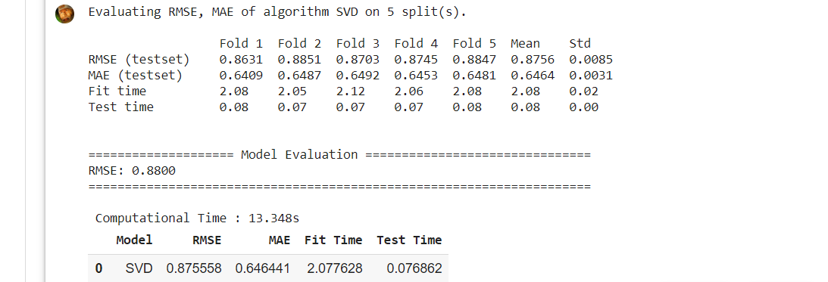
Fig 4.3.2: RMSE Result for SVD model

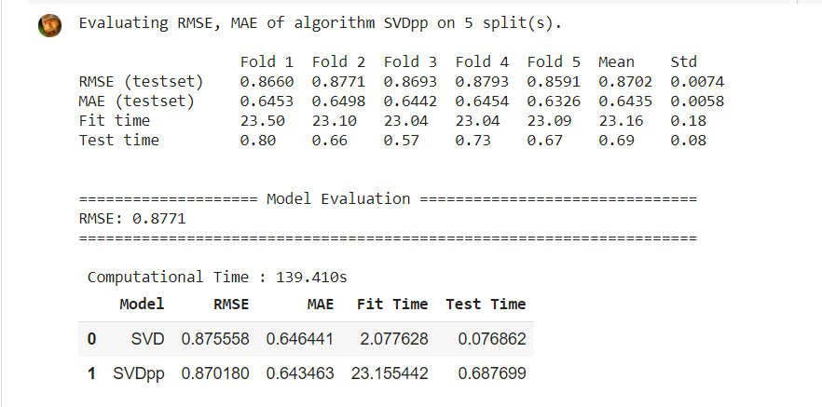 Fig 4.3.3:RMSE Result for SVDpp mode

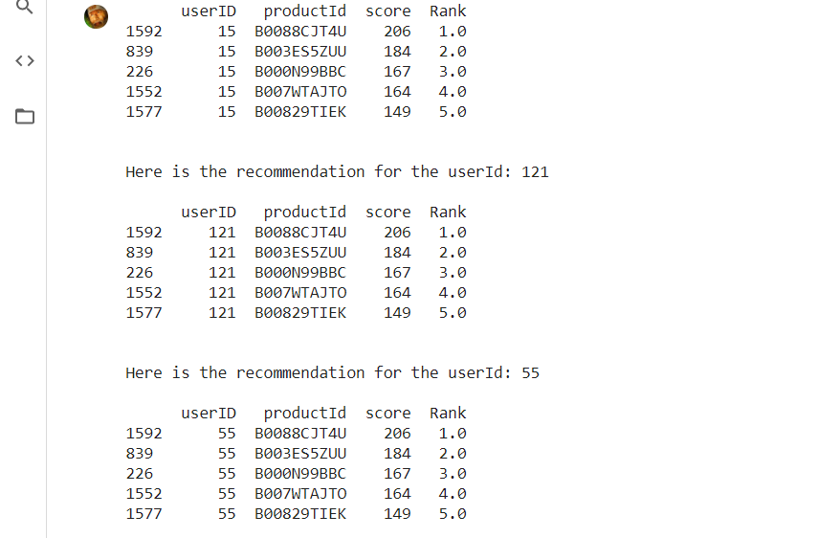

Fig 4.3.1: Result for Personal Recommendation Model Diagram

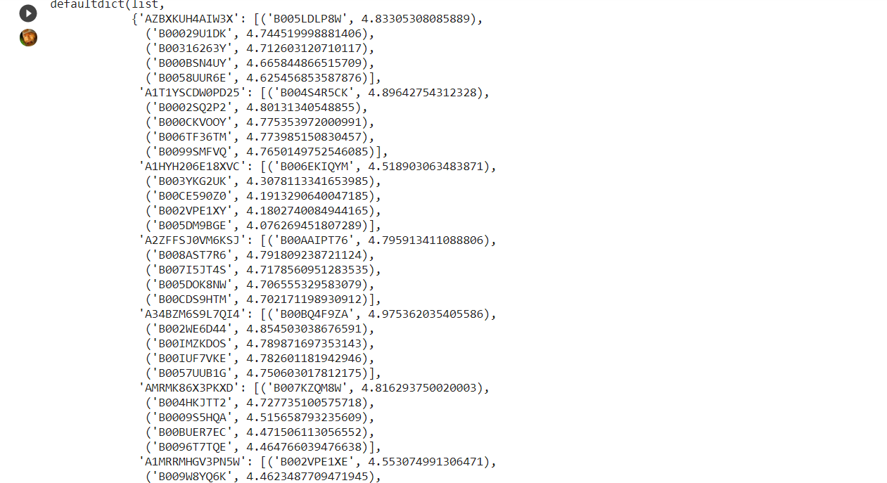
Fig 4.3.5:Recommendations using SVD model

5. CONCLUSION AND FUTURE SCOPE
Recommendation systems have a huge impact on today’s technological world. Recommender systems are a powerful new technology for extracting additional information for a business from its user databases. These systems help users find items they want to buy from a business. Recommender systems benefit users by enabling them to find items they like. Conversely, they help the business by generating more sales. Product Recommender systems are rapidly becoming a crucial tool in E-commerce on the Web. Recommender systems are being stressed by the huge volume of user data in existing corporate databases, and will be stressed even more by the increasing volume of user data available on the Web. New technologies are needed that can dramatically improve the scalability of recommender systems. In this project we presented and experimentally evaluated a new algorithm for CF-based recommender systems. Our results show that techniques hold the promise of allowing CF-based algorithms to scale to large data sets and at the same time produce high-quality recommendations.

6. REFERENCES

[1] `Mohana,Ayush Jain-Development of Product Recommendation Engine By Collaborative Filtering and Association Rule Mining Using Machine Learning Algorithms,2020.
[2] BardulSarwar et.al., “Item-based Collaborative Filtering Recommendation Algorithms”, in proceedings of the 10th International Conference on World Wide Web, Hong Kong, pp. 285-295, 2001.
[3] Ya-Yueh Shih et all., “Product Recommendation Approaches: Collaborative Filtering via Customer Lifetime Value and Customer Demands”, Journal of Expert Systems, vol.35(1), pp. 350-360, 2008.
[4] F.O. Isinkaye et.al., “Recommendation Systems: Principles, Methods and evaluation”, Journal of Egyptian Informatics, vol. 16(3), pp. 261- 273, August 2015.
[5] Masupha Lerato et.al., “A Survey of Recommender System Feedback Techniques, Comparison and Evaluation Metrics”, in proceedings of IEEE International Conference on Computing, Communication and Security, Mauritius, pp.1-4, December 2015.

